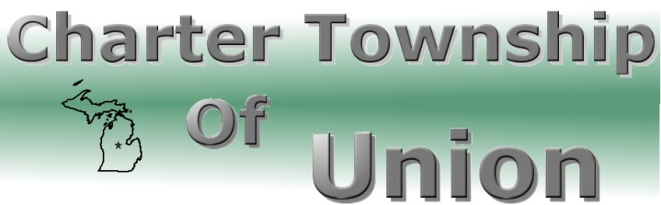

BOARD OF TRUSTEES
Regular Meeting
September 26, 2012
7:00 p.m.

- CALL MEETING TO ORDER

- PLEDGE OF ALLEGIANCE

- ROLL CALL

- PUBLIC COMMENT: Restricted to three minutes regarding issues on this agenda

- REPORTS/BOARD COMMENTS

- APPROVAL OF AGENDA

- CONSENT AGENDA
- Communications
- Minutes – September 12, 2012
- Bills
- Payroll
- 2.5.10 Cash Flow Ratio
- 2.10 Communication and Support to the Board
- 4.1 Unity of Control

- BOARD AGENDA
- 5000 lb. Pneumatic Fork Truck
- Ordinance 2012-06 – Human Rights Ordinance
- 2012 Audit
- Fall 2012 2% Request
- 2013 Budget Discussion

9. EXTENDED PUBLIC COMMENT

10. FINAL BOARD MEMBER COMMENT

11. ADJOURNMENT

